Yes Jesus Loves me

The New National Baptist Hymnal‎ #465 Key C
※
Yes, Jesus loves me×3 The Bible tells me so.

- Jesus loves me! This I know, / For the Bible tells me so.
Little ones to Him belong; / They are weak, but He is strong

- Jesus loves me! He who died / Heaven’s gate to open wide;
He will wash away my sin, / Let His little child come in.

- わが主イエス、わが主イエス、
わが主イエス われをあいす。

- 主われを愛す、主は強ければ / われ弱くとも 恐れはあらじ

- わが罪のため さかえをすてて / 天よりくだり 十字架につけり。

- みくにの門を ひらきてわれを / 招きたまえり、いさみて昇らん。

- わが君イエスよ、われをきよめて / よきはたらきを なさしめたまえ。

< Other verses>
Jesus loves me! This I know, / As He loved so long ago,

お薦めYou Tube: Israel & New Breed
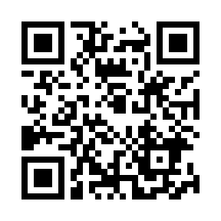
https://www.youtube.com/watch?v=LeGGwxYKt5E
Taking children on His knee, / Saying, “Let them come to Me.”

Jesus loves me when I'm good, / When I do the things I should,
Jesus loves me when I'm bad, /Though it makes Him very sad.

Jesus loves me still today, / Walking with me on my way,
Wanting as a friend to give / Light and love to all who live.

Jesus loves me! Loves me still / Tho' I'm very weak and ill;
That I might from sin be free /Bled and died upon the tree.

Jesus loves me! He will stay / Close beside me all the way;
Thou hast bled and died for me, / I will henceforth live for Thee.

*****
Yes, Jesus loves me Yes, Jesus loves me Yes, Jesus loves me The Bible tells me so
ソ ミソ ラ ド ソ ミド ミ レ ソ ミソ ラ ド ラ ソド ミ レ ド

Jesus loves me! This I know, / For the Bible tells me so.
ソミ ミ レ ミ ソ ソ / ラ ラ ドラ ラ ソ ソ

Little ones to Him belong; / They are weak, but He is strong
ソミ ミ レ ミ ソソ / ラ ラ ソ ド ミ レ ド
映画Lady Killerのワンシーンより
参考you tube音源です。

https://www.youtube.com/watch?v=1aRT-59MBqg
映画Lady Killerのワンシーンより
参考you tube音源です。
https://www.youtube.com/watch?v=1aRT-59MBqg

